Batch: A1 ____
Roll No.: 16010123012
Experiment No.: 02
Grade: AA / AB / BB / BC / CC / CD /DD

Title: Virtualization in Cloud using Oracle VirtualBox or KVM

Objective:
To understand the concept of virtualization in cloud computing by creating and managing virtual machines using Oracle VirtualBox or KVM

Expected Outcome of Experiment:

CO | Outcome
CO2 | Investigate the system virtualization and outline its role in enabling the  cloud computing System model

Books/ Journals/ Websites referred:

Abstract:

Virtualization is a method of separating a service from its underlying physical infrastructure. It involves creating a virtual replica of a computing resource, such as computer hardware, using specialized software. Initially developed during the era of mainframes, virtualization allows multiple operating systems and applications to run simultaneously on the same hardware. This enhances hardware utilization and flexibility by enabling the concurrent execution of different software environments.

Related Theory: -

Linux KVM
Kernel-based Virtual Machine (KVM) is a complete virtualization solution for Linux operating on x86 hardware with Intel VT or AMD-V support. It consists of:
- A processor-specific module (kvm-intel.ko or kvm-amd.ko).
- A loadable kernel module (kvm.ko), which provides the fundamental virtualization architecture.
KVM enables multiple virtual machines (VMs) to run unmodified Linux or Windows images. Each VM has access to private virtualized hardware, including a network card, disk, and graphics adapter. KVM is open-source software, and since Linux kernel version 2.6.20, its kernel component has been integrated into the mainline Linux kernel. As of version 1.3, its user-space component is part of mainstream QEMU.

Oracle VirtualBox
Oracle VM VirtualBox is a type-2 hypervisor for x86 virtualization, developed by Oracle Corporation. It was originally created by InnoTek Systemberatung GmbH and later acquired by Sun Microsystems in 2008, which was then purchased by Oracle in 2010.
VirtualBox supports multiple host operating systems, including Microsoft Windows, macOS, Linux, Solaris, and OpenSolaris. It also has ports for FreeBSD and Genode. VirtualBox allows the creation and management of guest virtual machines running various operating systems such as Windows, Linux, BSD, OS/2, Solaris, Haiku, and OSx86.
A "Guest Additions" package is available for certain guest operating systems, improving performance—especially graphics—and enabling dynamic resolution adjustment when resizing the virtual machine window.

Virtualization
VirtualBox allows users to run multiple guest operating systems alongside a single host OS. Each guest OS operates within its own VM, which can be independently started, paused, and stopped. Depending on the underlying host hardware, users can configure each VM for either software-based or hardware-assisted virtualization.
Key features include:
- A shared clipboard for communication between host and guest OS.
- A virtualized network facility for seamless connectivity.
- Direct communication between guest VMs if properly configured.
Virtualization enhances system efficiency, optimizes resource usage, and provides a flexible computing environment.
Implementation Details:

- Include step wise screenshots in the document with proper heading for each screenshot.
- For important screenshots, also explain what is happening in the step

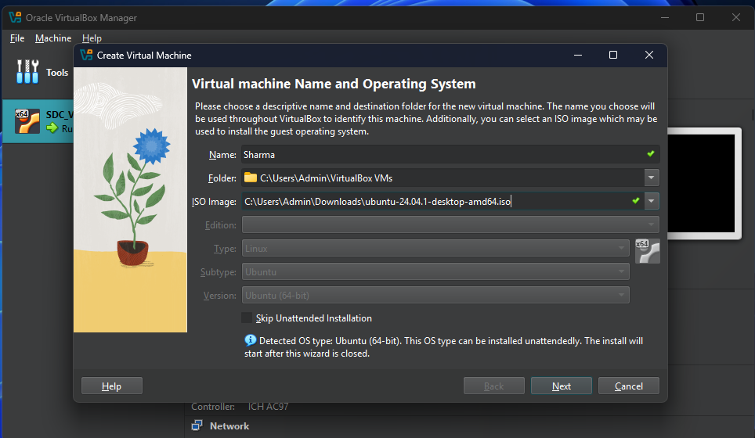
Loaded ISO Image File

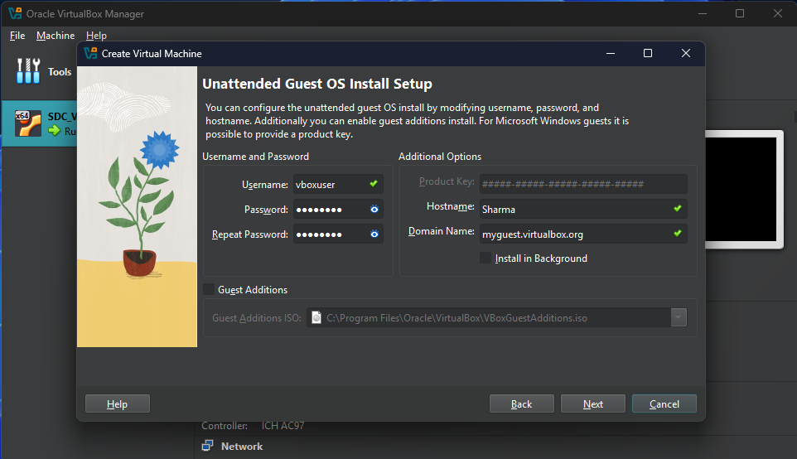
Setup Username and Password
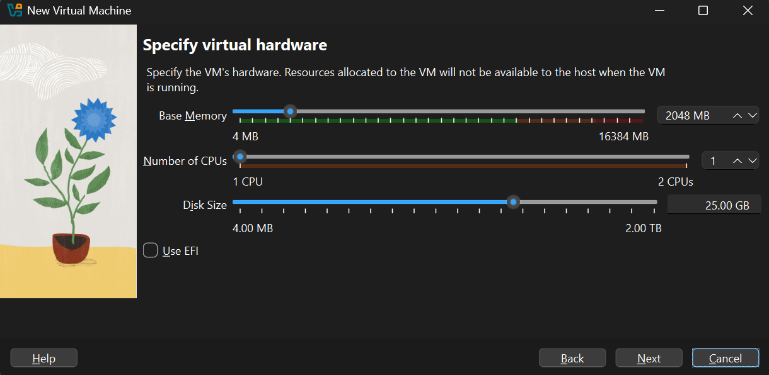
Allocated RAM, No. of processors and Storage

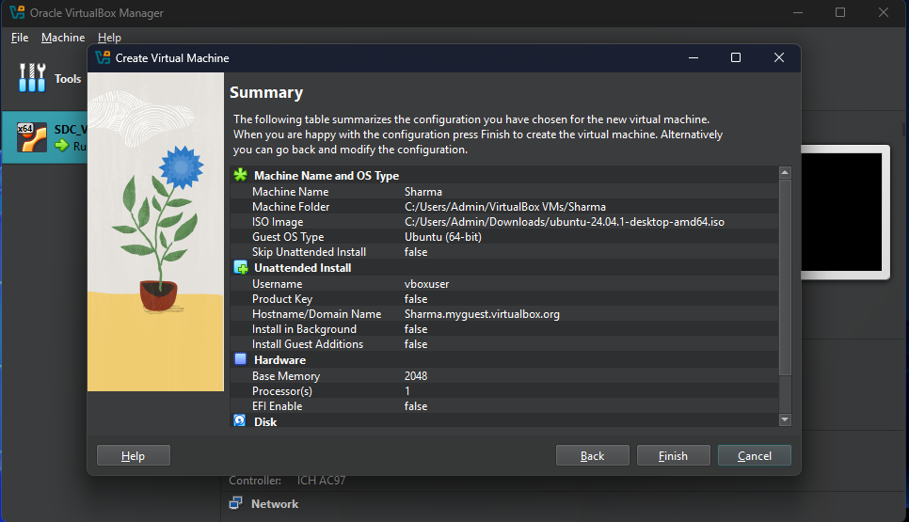
Review of the VM before Creation
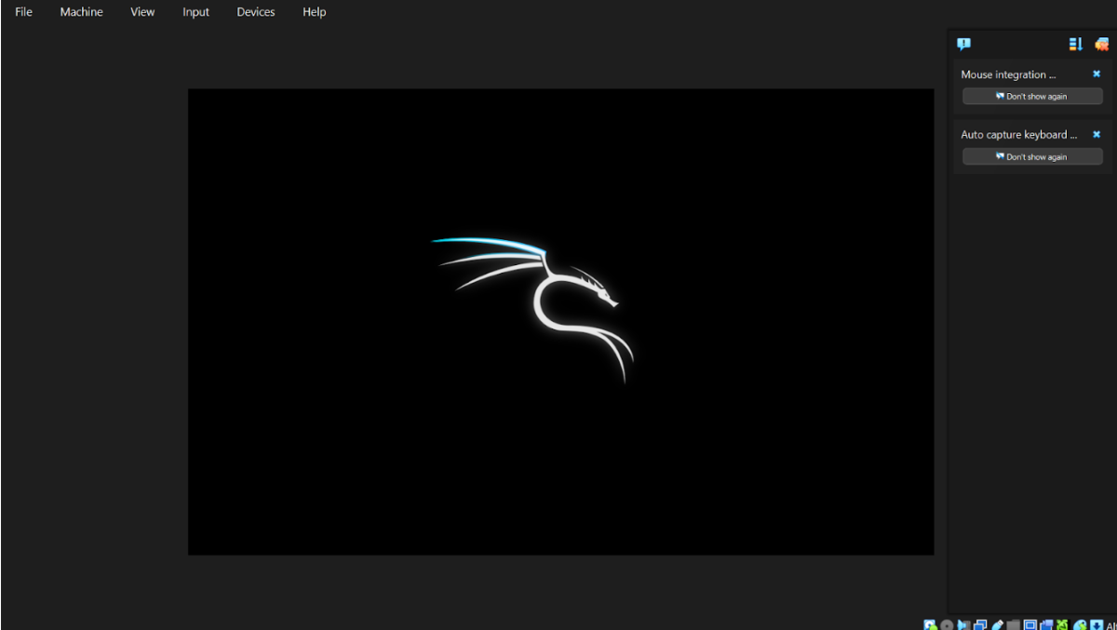
Successfully Running VM

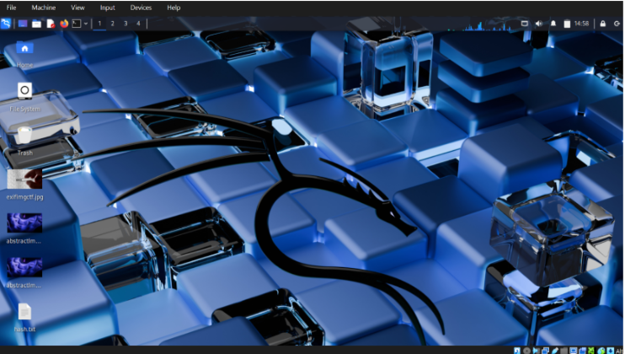
Desktop of the VM
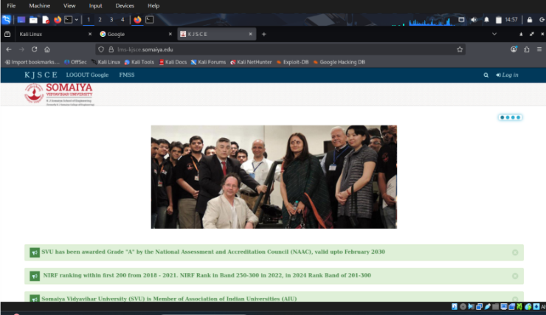
Browser Running in VM

Post Lab Questions:

- Does manual allocation of CPU and memory violate rapid elasticity? Justify your answer.
Yes, manual allocation of CPU and memory partially violates the principle of rapid elasticity. Rapid elasticity, as defined by NIST, refers to the ability of a cloud system to automatically scale resources up or down based on demand without human intervention. In VirtualBox or KVM, resources such as RAM, CPU cores, and storage are manually configured during VM creation. Any change requires the VM to be stopped and reconfigured manually. Therefore, the dynamic and automated scaling feature of cloud environments is not fully supported in standalone virtualization platforms.
- Which NIST cloud characteristics are not fully satisfied by VirtualBox/KVM? Give reasons.
VirtualBox and KVM do not fully satisfy the following NIST cloud characteristics:
• Rapid Elasticity – Resources are not automatically scaled; manual reconfiguration is required.
• Measured Service – There is no built-in metering or pay-per-use billing mechanism.
• Broad Network Access – Access is generally limited to local or configured networks, not universally accessible over the internet by default.
• On-demand Self-Service – Provisioning requires manual setup rather than automated provisioning through a service portal.
However, Resource Pooling is partially achieved, as multiple VMs can share the same physical hardware.
- Give one real-world example where virtualization alone is sufficient, and one where cloud computing is required.
Virtualization alone is sufficient in scenarios such as software development and testing environments within a college lab or company office. For example, running multiple operating systems on a single machine using VirtualBox for application testing does not require cloud infrastructure. Cloud computing is required in large-scale applications such as e-commerce platforms (e.g., online shopping websites) where automatic scaling, global access, load balancing, high availability, and usage-based billing are essential. In such cases, virtualization alone cannot handle dynamic user demand and distributed access requirements.

Conclusion:
In this experiment, virtualization was successfully implemented using Oracle VirtualBox or KVM to create and manage virtual machines. The practical exercise demonstrated how virtualization abstracts physical hardware to allow multiple operating systems to run on a single host system. Through configuration of CPU, memory, storage, and network settings, the working of hypervisors and resource sharing mechanisms was clearly understood. The experiment highlighted the role of virtualization as a foundational technology for cloud computing while also identifying its limitations in terms of elasticity, automation, and measured services. Thus, system virtualization was effectively investigated and its contribution to enabling the cloud computing model was outlined.

